Ideation Phase
Empathize & Discover

Date | 30-09-2026
Team ID | SWTID-2026-3179
Project Name | AI-Augmented Backend Development AI FitTrack API
Maximum Marks | 4 Marks

Empathy Map Canvas:
An empathy map is a simple, easy-to-digest visual that captures knowledge about a user’s behaviours and attitudes.

It is a useful tool to helps teams better understand their users.
Creating an effective solution requires understanding the true problem and the person who is experiencing it. The exercise of creating the map helps participants consider things from the user’s perspective along with his or her goals and challenges.
Example:


Reference: https://www.mural.co/templates/empathy-map-canvas

Empathy Map: AI FitTrack User (Rahul, a fitness enthusiast)
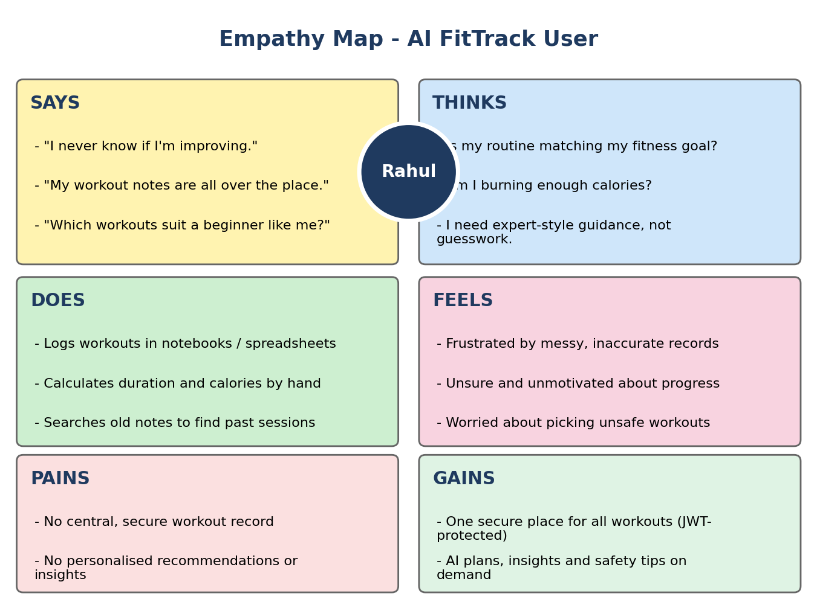
Rahul exercises regularly but records his workouts by hand. He struggles to organise his history, monitor progress and judge whether his habits match his goals, and he lacks professional guidance on which workouts suit his level. AI FitTrack addresses this with a secure workout tracker and Google Gemini-powered recommendations and insights.

